Exercise Questions on Conditional Formatting

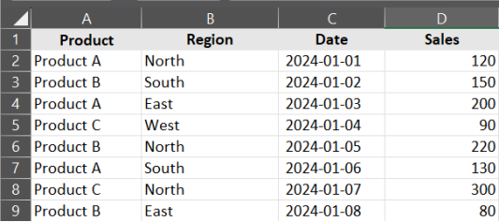

**Q1.** **Apply conditional formatting to highlight cells in the Sales column (D) with values greater than or equal to 150.**

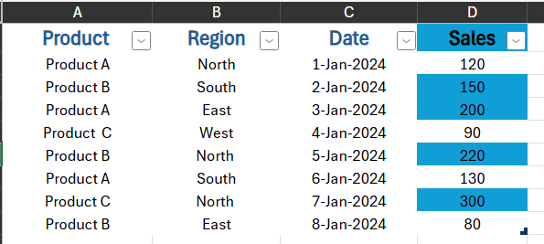

**Q2. Apply conditional formatting to highlight the entire row for entries where the Product is "Product A".**

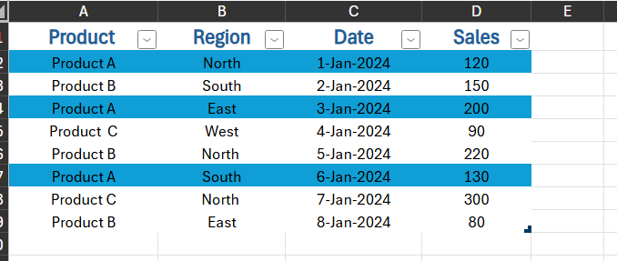

**Q3. Apply conditional formatting to highlight cells in the Date column (C) that fall within January 2024.**

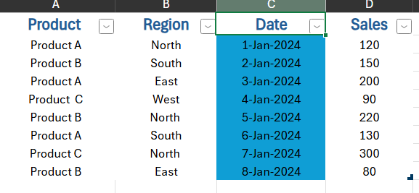

**Q4. Apply conditional formatting to highlight the top 3 sales values in the Sales column (D).**

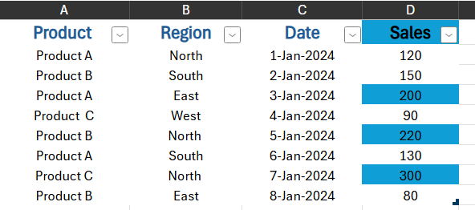

**Q5. Apply conditional formatting to highlight sales for "Product B" in the "North" region.**

